Backing Up Your SQL Database

It is important to make a back up of your database from time to time. It is equally important to make a copy of the backup and store it in a location other than your computer such as a flash drive or a network drive that is backed up by your local IT. Below are step by step directions for backing up your database.
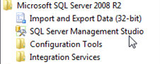
Step 1: Open Microsoft SQL Server Management Studio.
Start\All Programs\Microsoft SQL Server 2005 or 2008\SQL Server Management Studio

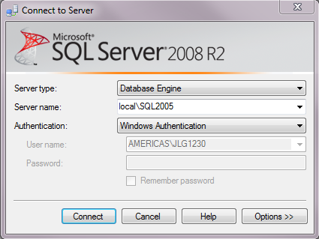
Step 2: Log into SQL Server. If you are the local administrator of your computer, you should be able to login with Windows Authentication. If you are not an administrator, you may need to login using SQL Authentication.
The best SQL account to log in with is sa. You should have the SQL password. If you do not, you may need to work with your local IT.

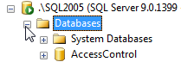
Step 3: Expand Databases by clicking on the + sign next to it. Your database should be listed below.
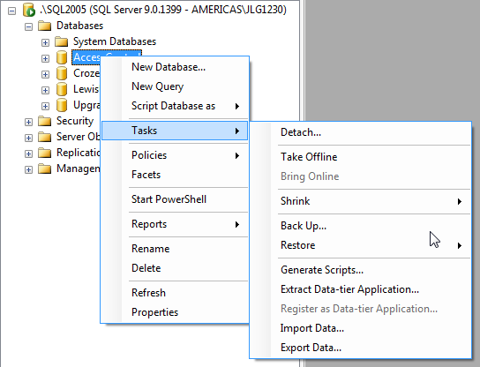

Step 4: Right click on your database. A fly out menu should appear. Click on the listed item “Tasks” and select “Backup” from the options.

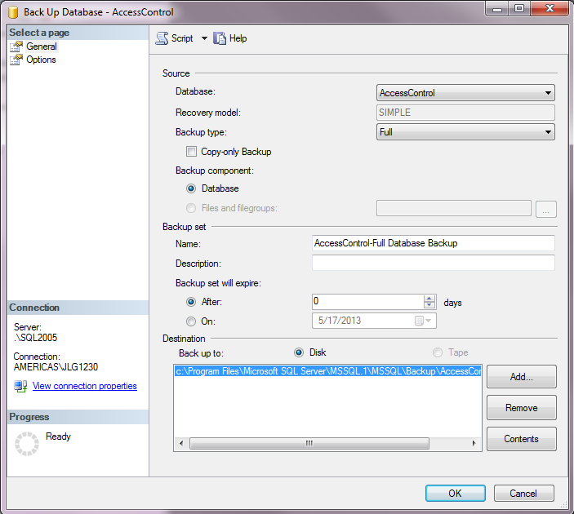
Step 5: Verify the correct database is selected. Verify the Back Up To path is correct. If it is not correct, or the backup file needs to be renamed, please click on the “Remove” button to the right of the destination text box. Click on the “Add” button to change the database back up location or backup name.

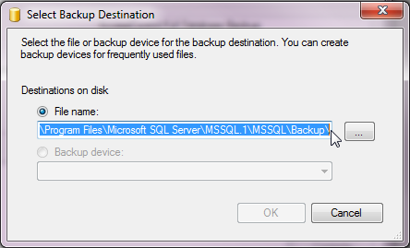

Step 6: Place the cursor at the end of the path listed and change the name for the backup file remembering to add the .bak extension to the end of the name. Also, limit special character use to _ and – in the naming convention. E.G. AccessControl_05172013.bak.
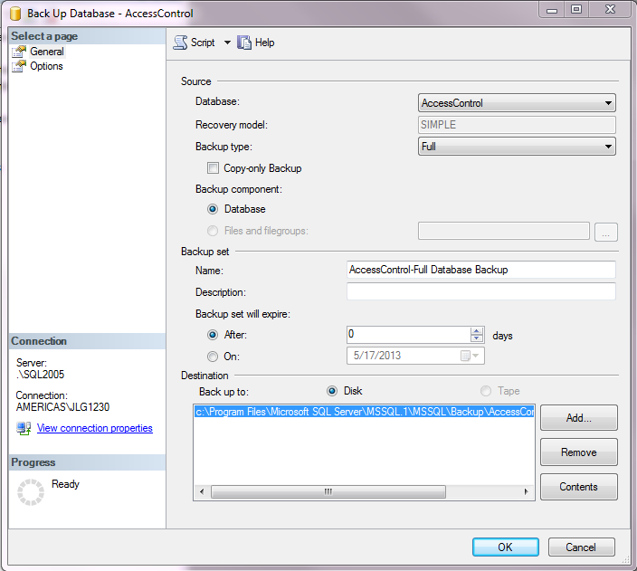

Step 7: Verify the correct name and path is listed in the Destination and click on the “Options” listing in the Select a page portion of the Back Up pop up.
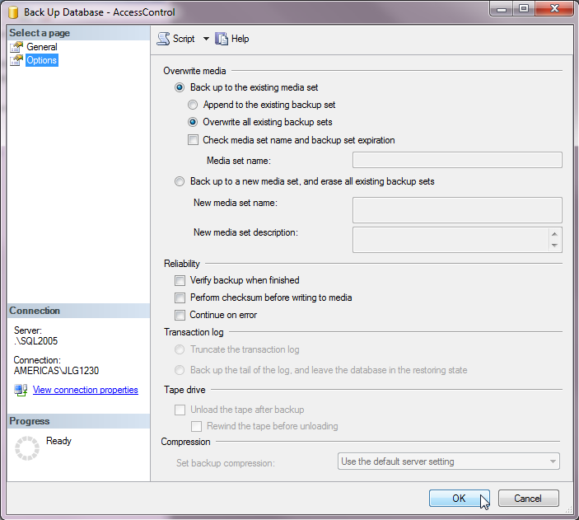

Step 8: Click on the radio button to Overwrite all existing backup sets” and click on the OK button in the lower right corner.
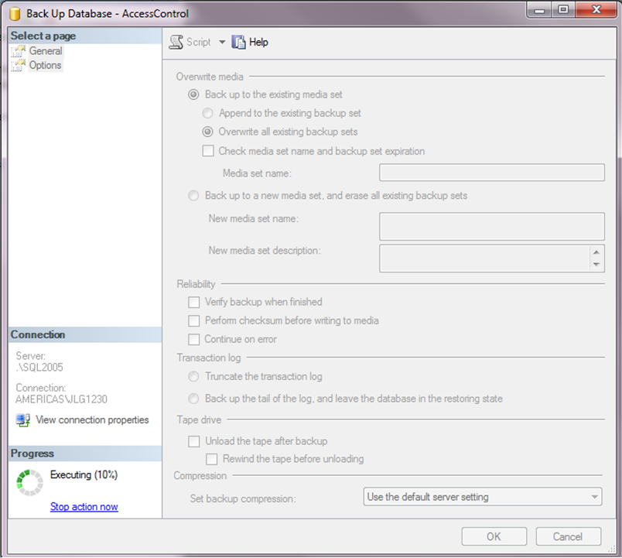

Step 9: The Progress Executing wheel should start incrementing until it reaches 100%.

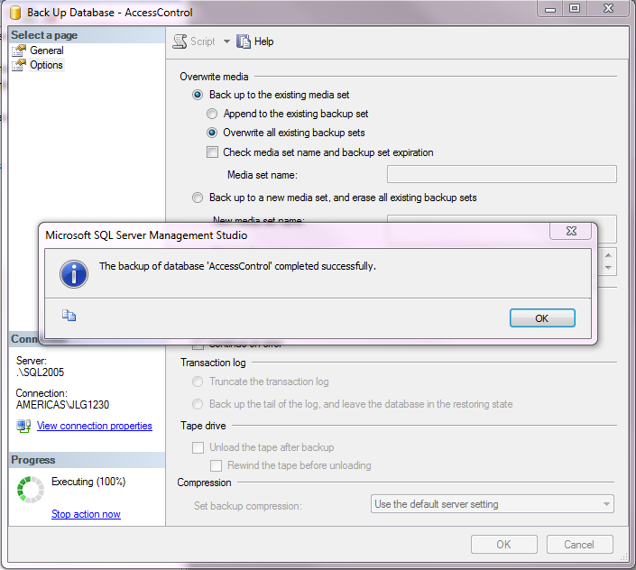

Step 10: Once the backup has completed successfully, a prompt will appear. Click the “OK” button.

Step 10: Navigate to the location where the backup should have written and make a copy of it to place on a resource other than the computer.

