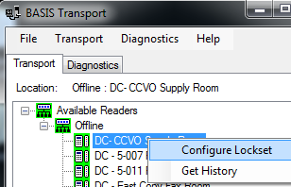  
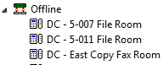 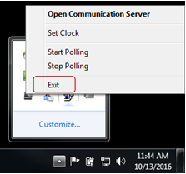

# Programming Reader

1. Open Transport Tray: Start>All Programs>Stanley Security Solutions>BASIS Transport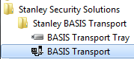
2. Your panels and readers should show

up in the program. Locate the   
reader you would like to program

and right click on it and click on

**Configure Lockset.**

# Downloading Single Reader

1. Click on the system tree icon to   
   expand the hardware tree.
2. Locate the Offline panel the   
   reader you would like to   
   download is attached to   
   and click on the right arrow to expand the hardware tree.
3. Right click on the reader you would like to download and click the download option. 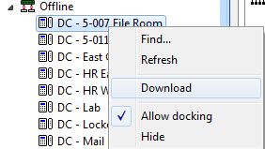
4. Sync completed successfully once the reader has successfully downloaded.
5. Close the programs, system administration, BASIS Com Server, and BASIS Transport tray.

# Downloading Entire Panel

1. Open System Administration, Start>All Programs>B.A.S.I.S>System Administration
2. Open Access Panels: AccessControl>Access Panels
3. Locate the **Offline** tab and click on it to display offline lock access panels.
4. Right click on the access panel to download the offline panels. Select the **Download** option.  
    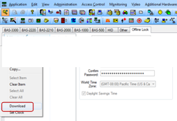
5. You will be prompted that this will force a full system download. Click on the **OK** button.  
   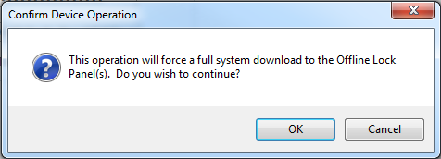
6. Through the download process you will see notifications from the BASIS Transport Tray in the lower right corner by your clock. Once the download is completed, you will see a Sync Completed Successfully message. 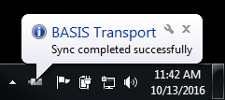

# Close Programs

1. Expand system tray by clicking on the   
   up arrow and right click on the COM   
   Server to exit that program. Complete   
   the same steps with the BASIS   
   Transport Tray.
2. Close system administration.

# Downloading Using BASIS Transport Tray

1. Login to System Administration and make programming changes to users, access levels, time zones, etc.
2. Once programming changes have been completed, you are ready to download your readers for programming.
3. To download your offline readers, you will open the BASIS Communication Server by navigating to Start>Programs>BASIS ET 694> Services and Support> Communication Server.

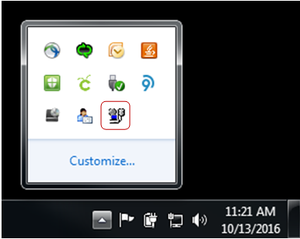

Figure 1: The communication server will open and run in the lower right corner of your screen.

1. Open Transport Tray Start>Programs>Stanley Security Solutions>Stanley BASIS Transport>BASIS Transport Tray
2. Both the BASIS COM Server and the BASIS Transport Tray Should be running in your system tray. 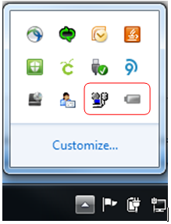

# Using BASIS Transport and Transport Tray on the BASIS Computer